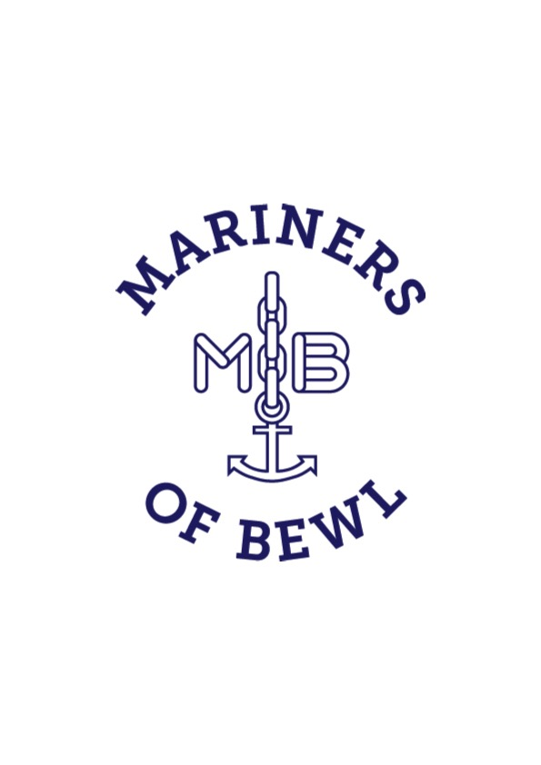
Members sailing their own boats as part of MOB sessions

MOB welcomes members who wish to use their own boats to join the MOB fleet as part of MOB sailing sessions.

In order to comply with safety and insurance requirements, MOB members using their own boats as part of MOB sailing session must:

- be full members of Bewl Water

- agree to abide by the sailing instructions given by the duty Senior Sailing Instructor

- provide MOB with details of their boat insurance by completing the form below and returning it with their membership form and annual subscription to the MOB Treasurer

MEMBER'S BOAT INSURANCE:

Member's name…………………………………………………………..

Boat Class………………………………………………………………..

Boat name………………………………………………………………..

Name of insurance company…………………………………………..

Expiry date of insurance………………………………………………..

